# Swiss Timing Race Committee App

Usecase:

Swisstiming employee or volunteer on Start and Finish Boat supporting the raceofficer

The user must be introduced to the software

Providing high data quality and reliable connectivity

UI:

Very technical, views based on simple elements that are not really intuitive

Accustical signals:

If clock is not synchronized

Pre-race phase started

10 seconds before start a countdown starts

System:

Windows CE 6.00

Start:

Choose between Start Terminal and Finish Terminal

Start Terminal:

* Menu with some Options
  + Select Races
    - All Races identified by class and race number like “N17 R1”
    - Filterable by class
  + Options
    - Time Zone Offset
    - Start sequence Duration
    - Checkbox: Auto Select next race if more then one race is selected
* Wind Info
  + Wind direction
  + Wind speed
  + Object where the wind was measured (e.g. mark 1)
  + History with the earlier entered dates
* Set Starttime
  + Starttime
  + Countdown
* Set Course Areas
  + Areas from predefined Lists
* Set Course Layout
  + Course Layouts as International Standards (see [Course Illustrations](http://www.santander2014.com/uploaded_files/Document_250_20130907194826_en.pdf) from Santander2014)
* Set Weather
  + Conditions
    - Standards from ISAF but also “heavy snow” and “tropical storm”
    - Set Temperature
    - Set Humidity
* Time (red if not synchronized)
* Flaggs
  + GenRecall
  + Postpone
  + Abandon
  + BlackFlag
  + Oscar
  + Romeo
* IRM
  + Preselect Competitors by characters contained in Competitor Identifier like GER56
  + States
    - OCS
    - BFD
    - DNS
    - DSQ
    - DNC
    - DNF
    - SCP
    - RET
  + History of entered States, if wrong delete the state from the history
* Select and switch between all the races selected in the options

Finish Terminal:

* Load Races via menu
  + Filter by class
  + Select multiple races
* Set time impulses
* Insert Competitors via quick selection with character contained in boatidentifier (GER23)
* Insert blank times
* Insert blank competitor
* Move, Delete Boats
* IRM
  + BFD
  + DNE
  + DSQ
  + SCP
  + DNC
  + DNF
  + DNS
  + RAF
* Resend Results via menu

# Feedback Volunteer User Racecommitee App SAP

Course Area changed during the races

* That means selection via Event->Area->Class would not work
* Buttons were not recognized as Buttons
* Start as Demo-User did not help the user and so maybe it should be a switch in the options for showcases
* Set course + Set wind was not recognized as clickable and after it was told it was not clear as two different options
* “Store Data” Button in wind settings is confusing. Either always or never use store buttons
* Flags were recognized and used well for postponing the race (but for “not sailors” it should have titles)
* Actual up and down flags did not help at all and the frame containing it was not recognized as “view only”
* Sound signals were missed because the user got used to it by Swiss Timing terminal
* Handling of the second race was much easier than the first one. That means the software is easy to learn
* Individual Recalls and everything connected to IRM is missing because we do not have access to competitors in the app
* Finishers will be an important part and for Swiss TIMING it is important to have the exact finishing time of every competitor
* iPhone Users do not find the back button. So if a on device tutorial is planned, it should explain the back button
* Two classes are sometimes starting and finishing at the same time. That should be in mind of a developer for finisher selection

About the user: Volunteer, used to sailing domain, uses internet for information about sailing, does not think all the swiss timing hardware is a barrier

# Feedback Volunteer User Racecommitee App SAP

* Good that user does not need to hold it, on the other hand it is bad because it is not variable User was too small to use it-> a good solution would be to have a clip where one could easily fix the tablet
* Sun is a problem because the screen is not bright enough/ ebook reader screen was proposed because you can use it in direct sun
* Separated start and finish boats are good, but if it is the same boat only one device should be onboard
* Sound signals are good
* There was a second tablet (Windows) on the boat from the Isaf to show all flag changes at the website. That should be done all in one. It is not possible to set the papa flag on the device but it would be possible to send this event automatically
* The race tech office must call to get some information, so why not use the chat function?
* Boat Identification if sailing under a different sail is not possible
* Rethink the acoustic signals before and during the race and make them optional
* Object selection in the set wind screen could confuse
* IRM is easy to handle
* The race officer is not using the tablet at all
* History for fast wind data selection is really good but it should be clear that it is the history and selectable
* The order of the proposed Finishers is unclear
* The selection via single characters is really useful
* DNS,DNC,DNF teams should not be shown in the proposed finisher list

Race Officer: “It would be very important to see live wind data and the GPS Position of the boat at the tablet. That would help. Everything else helps media and visitors but not those on water”

Terminals are fixed at the boat 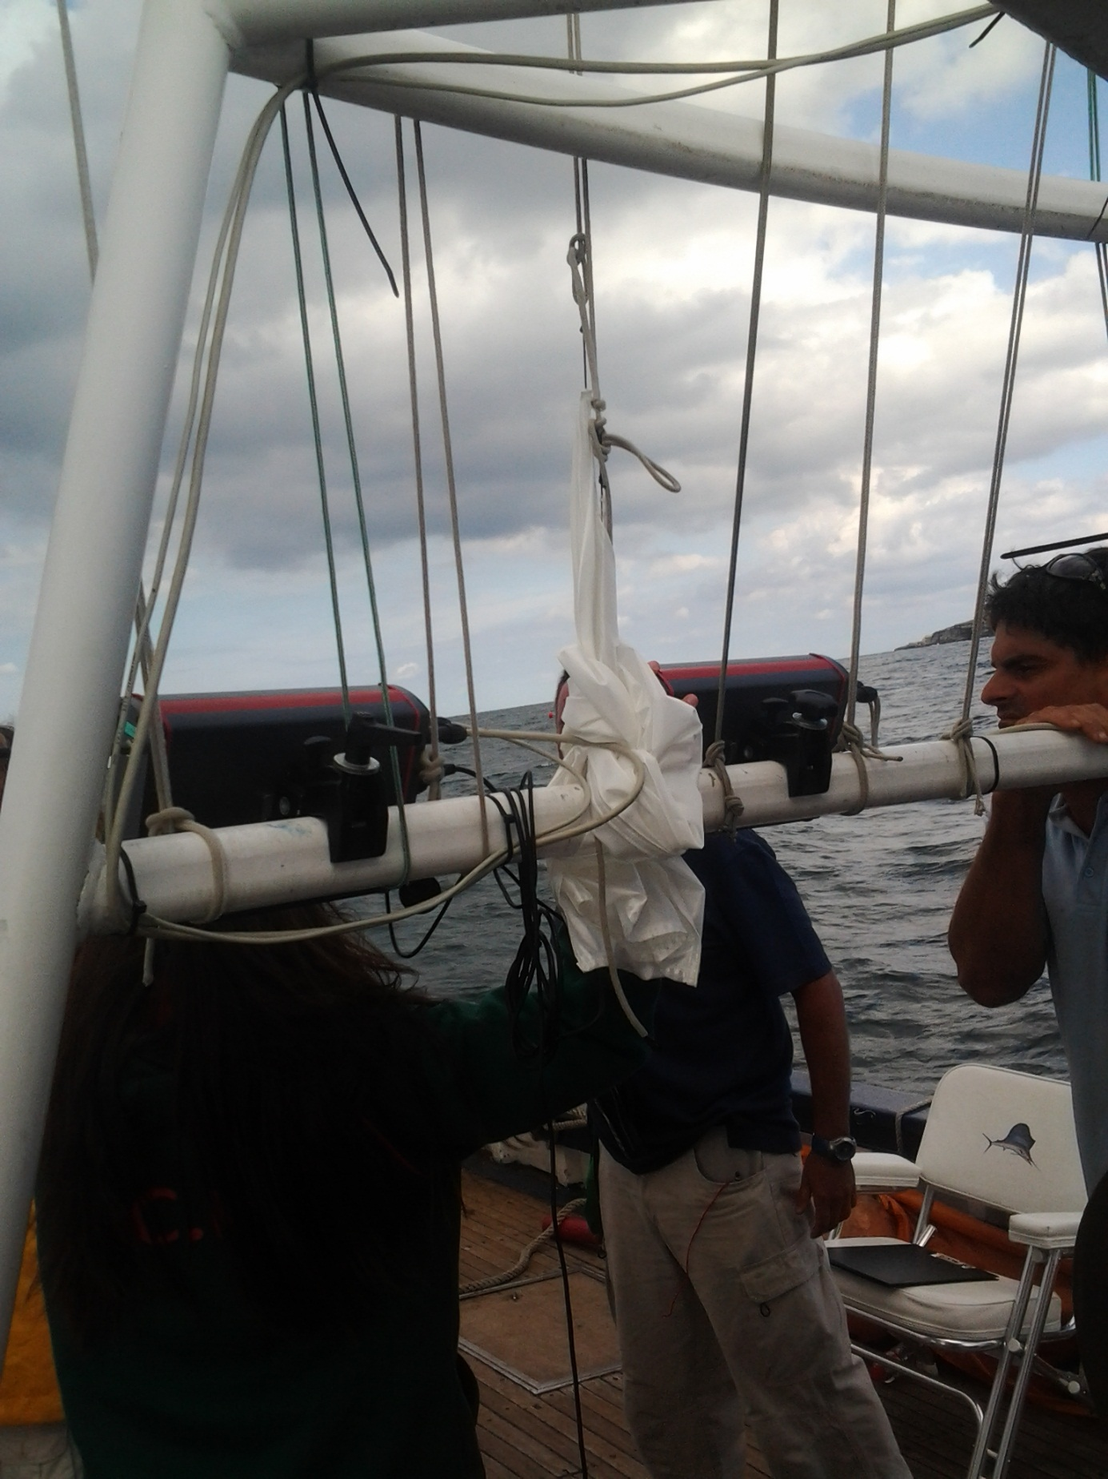Start and Finish Terminal with Finish Push Button

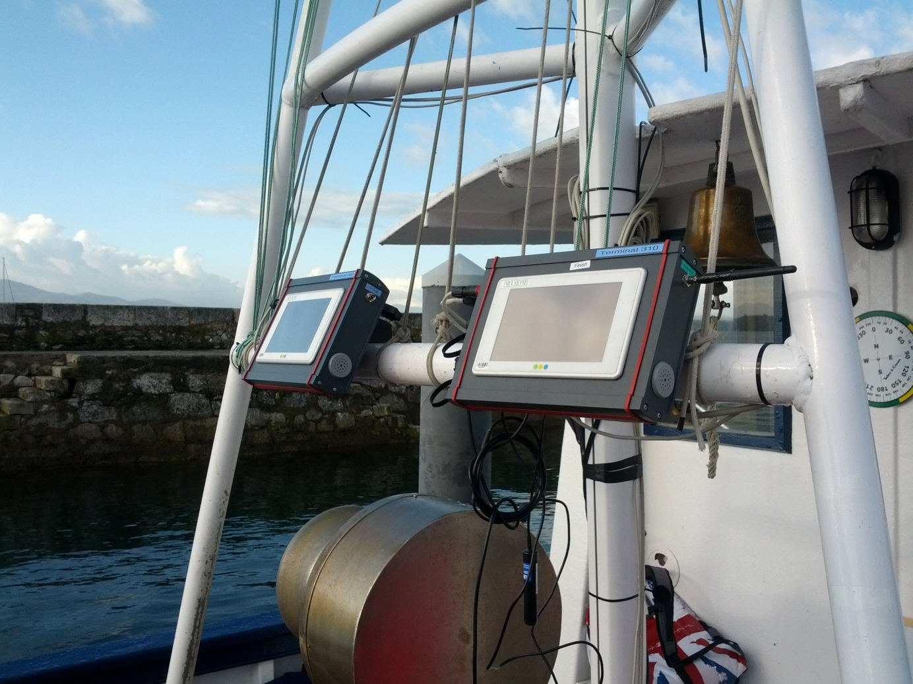

Two Antennas for Sending and two for receiving

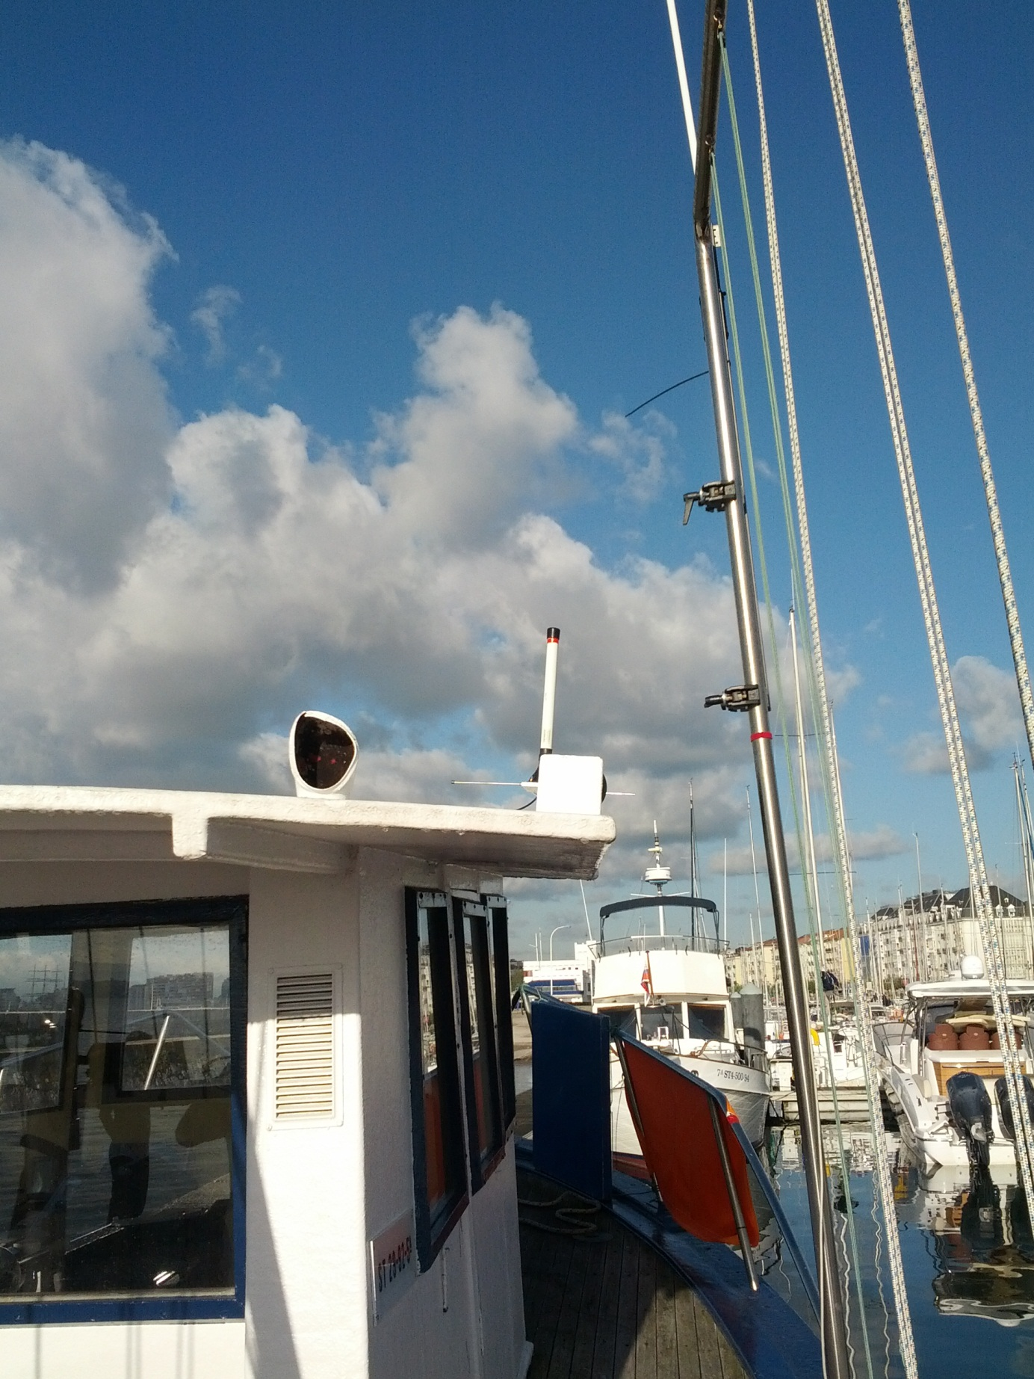

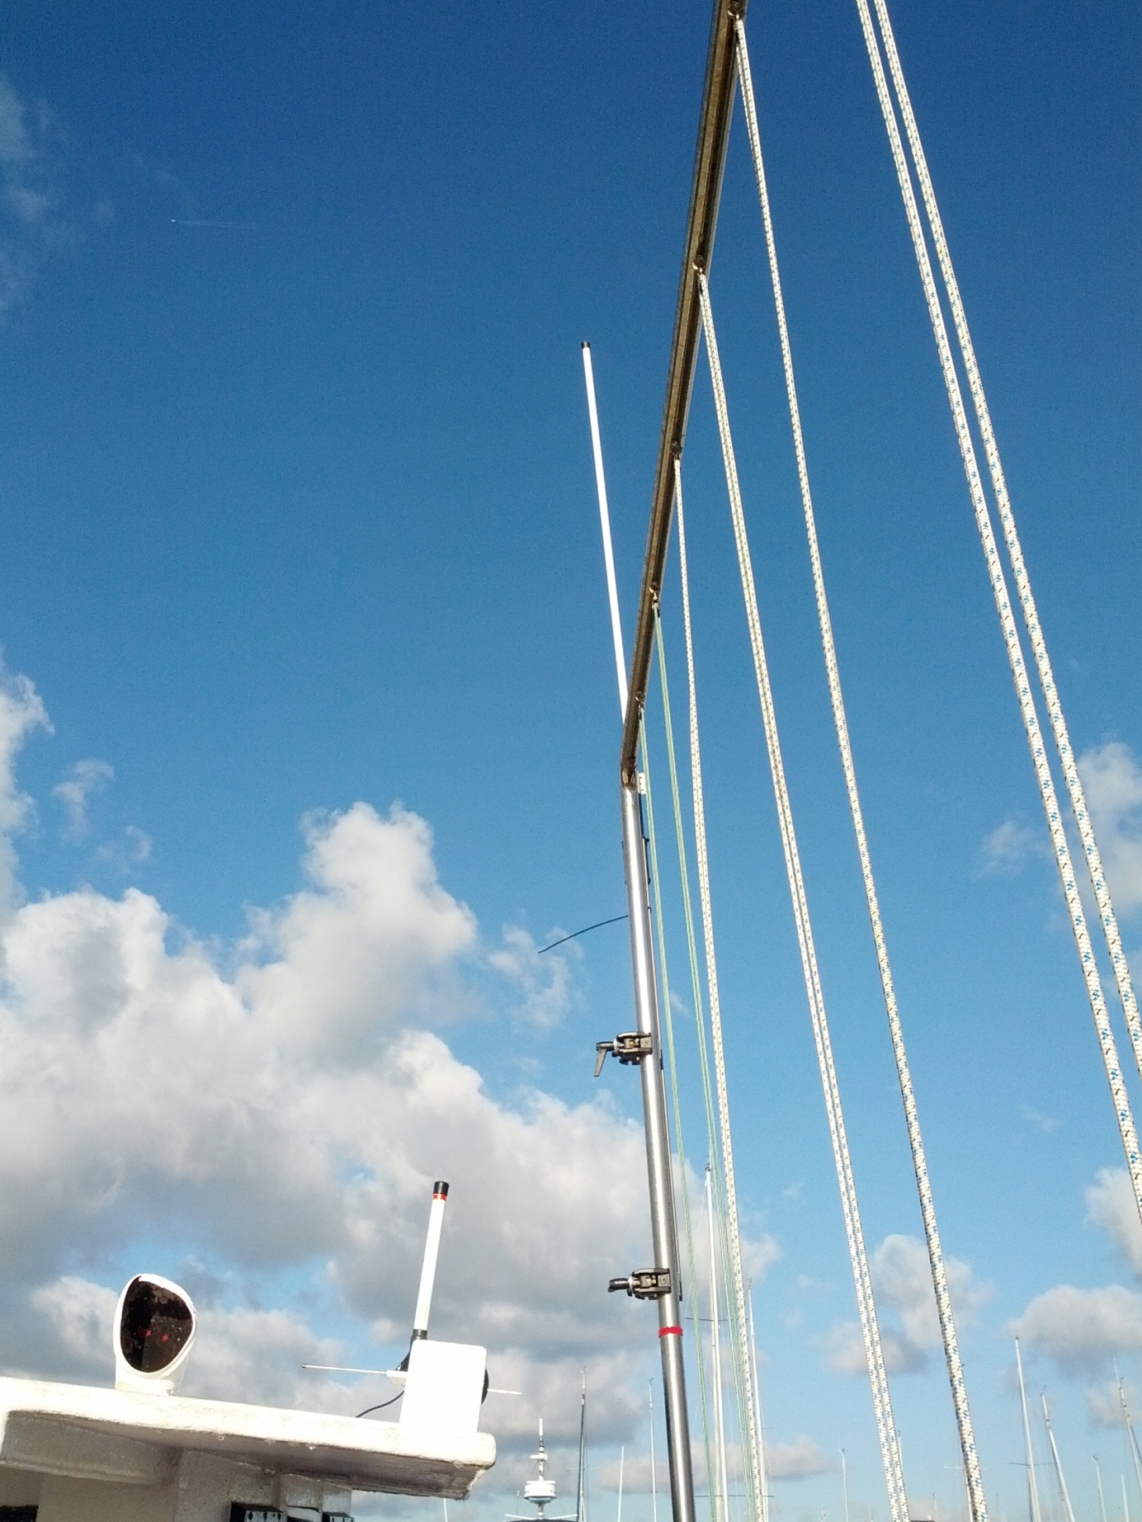

GPS modul

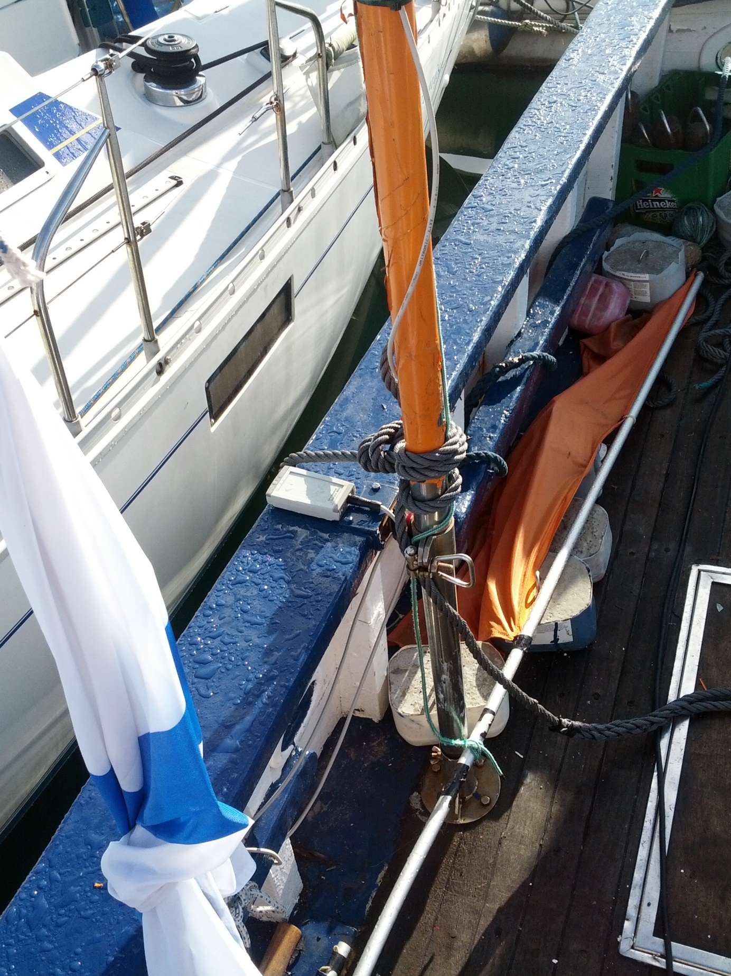Routing Equipment

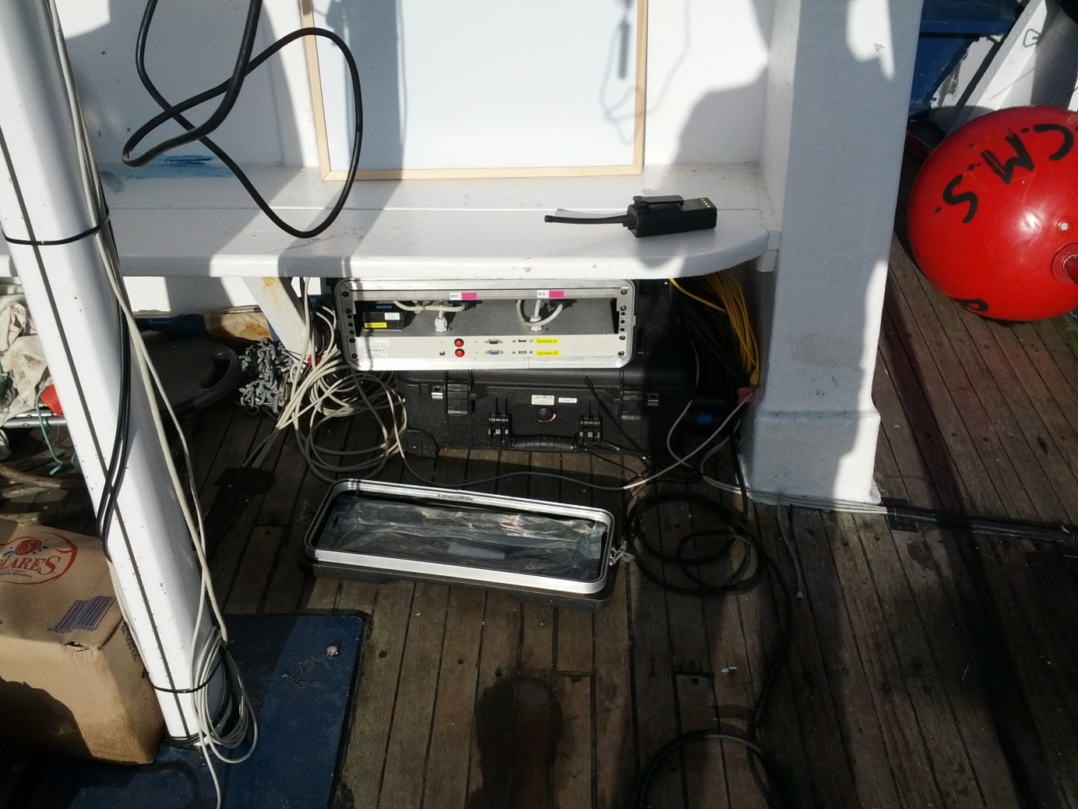

Buoy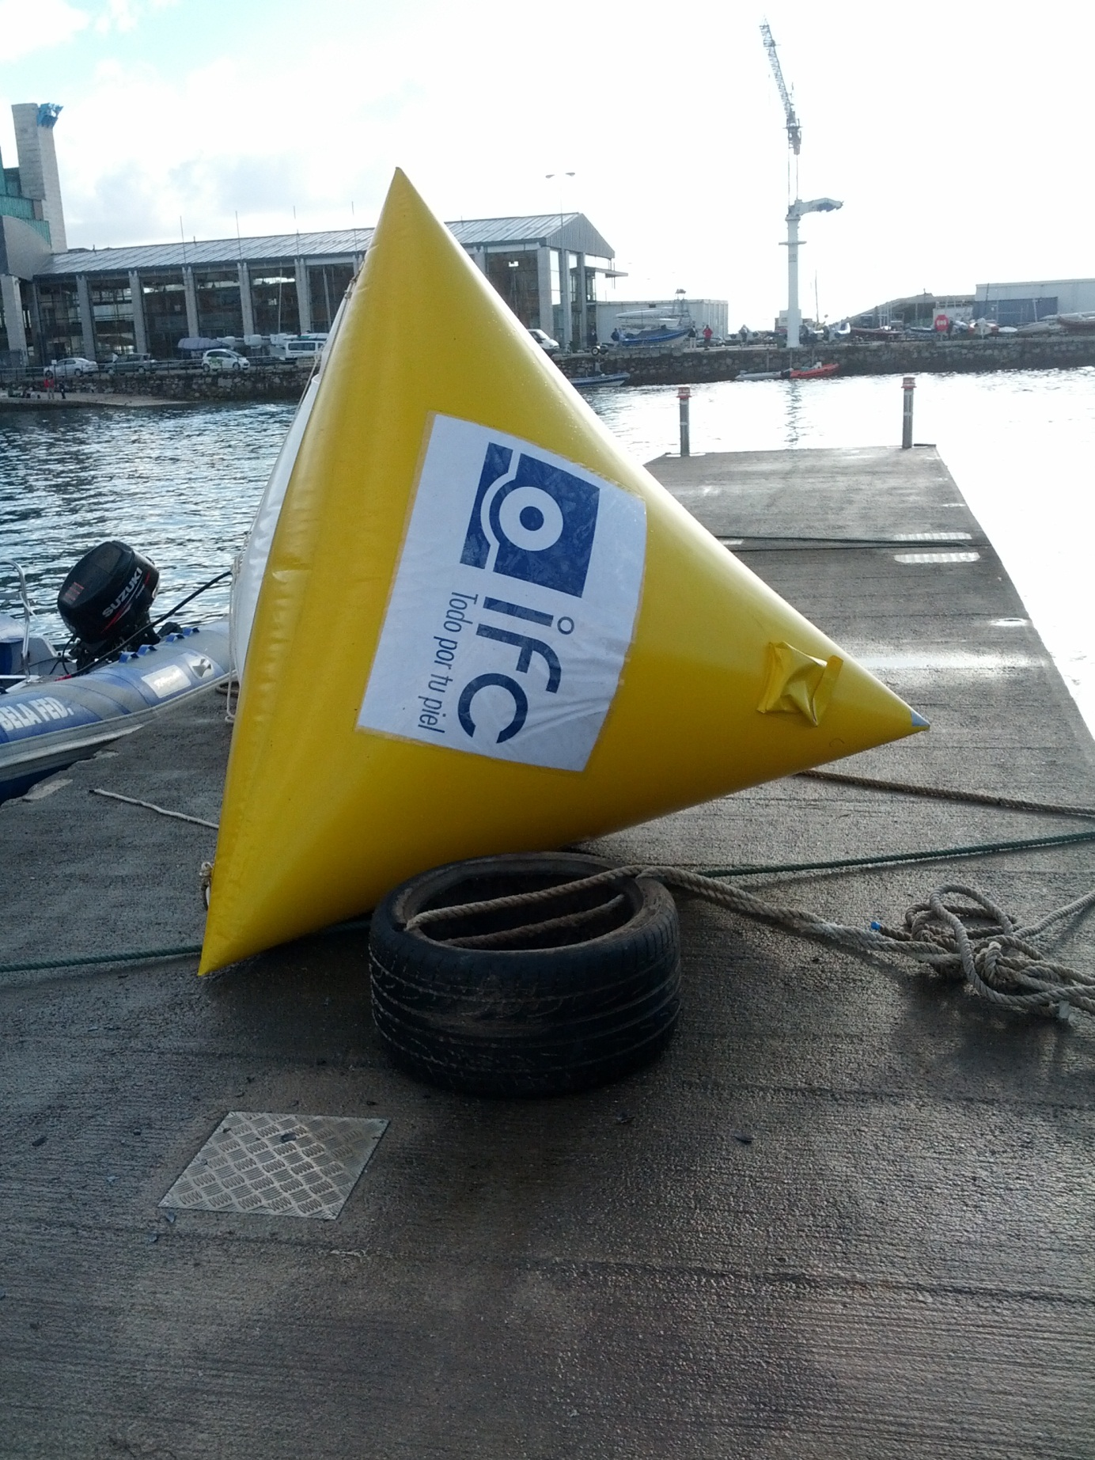Power Connection

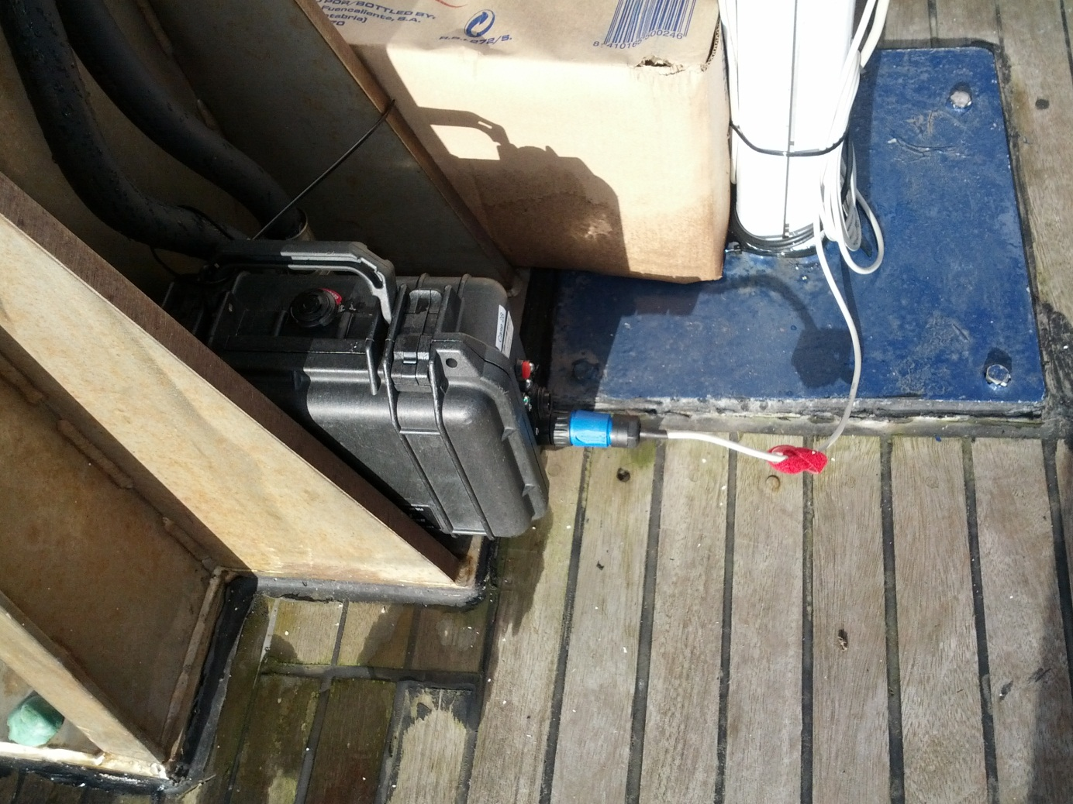

In Use

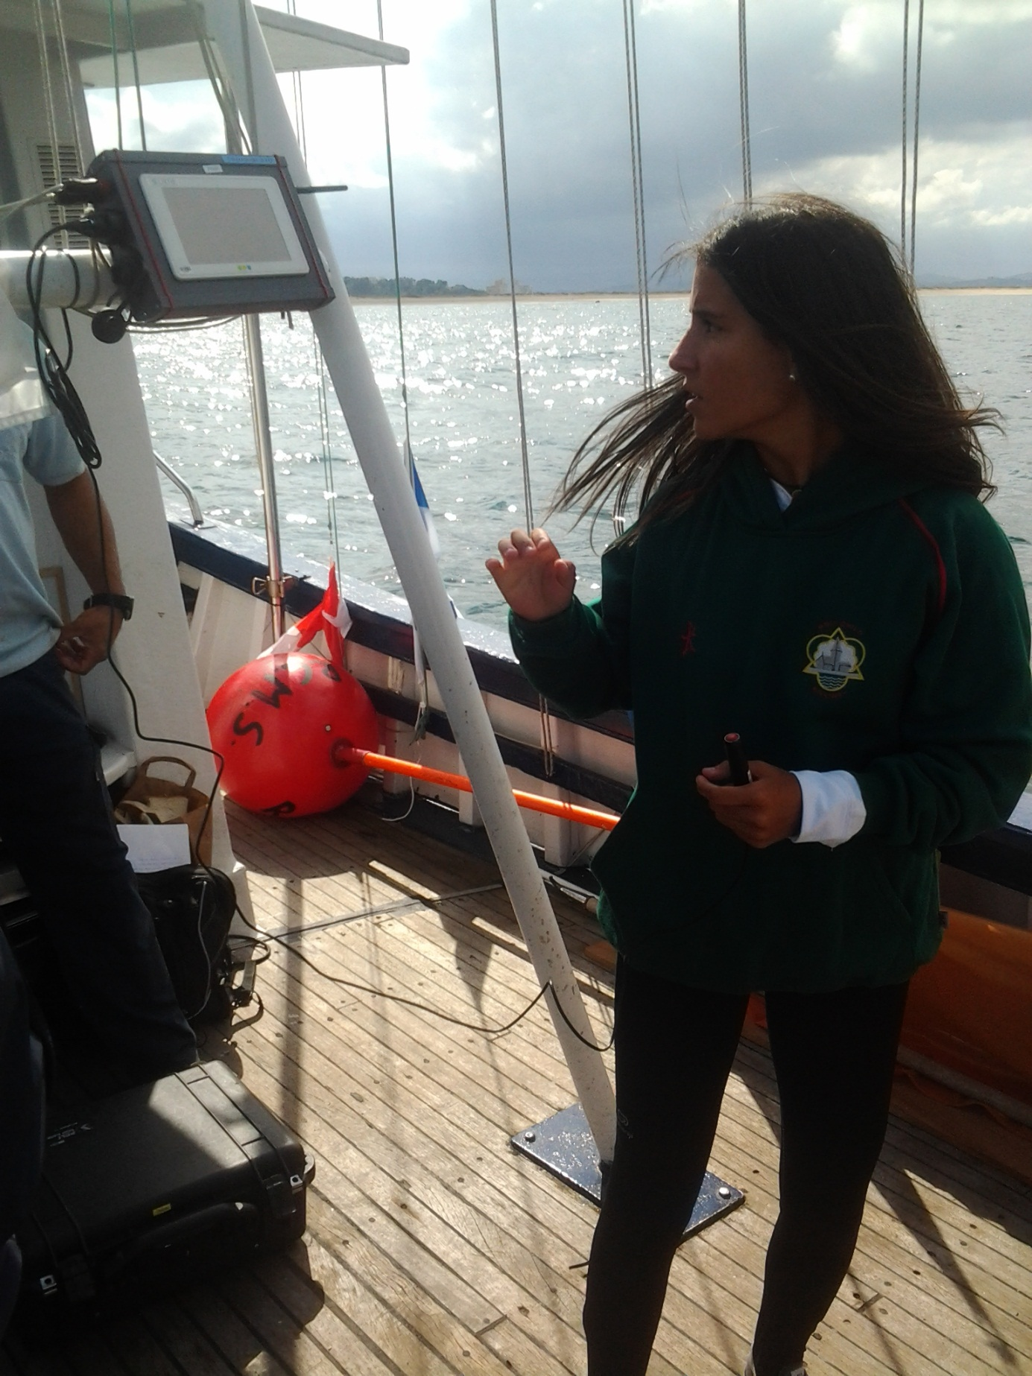

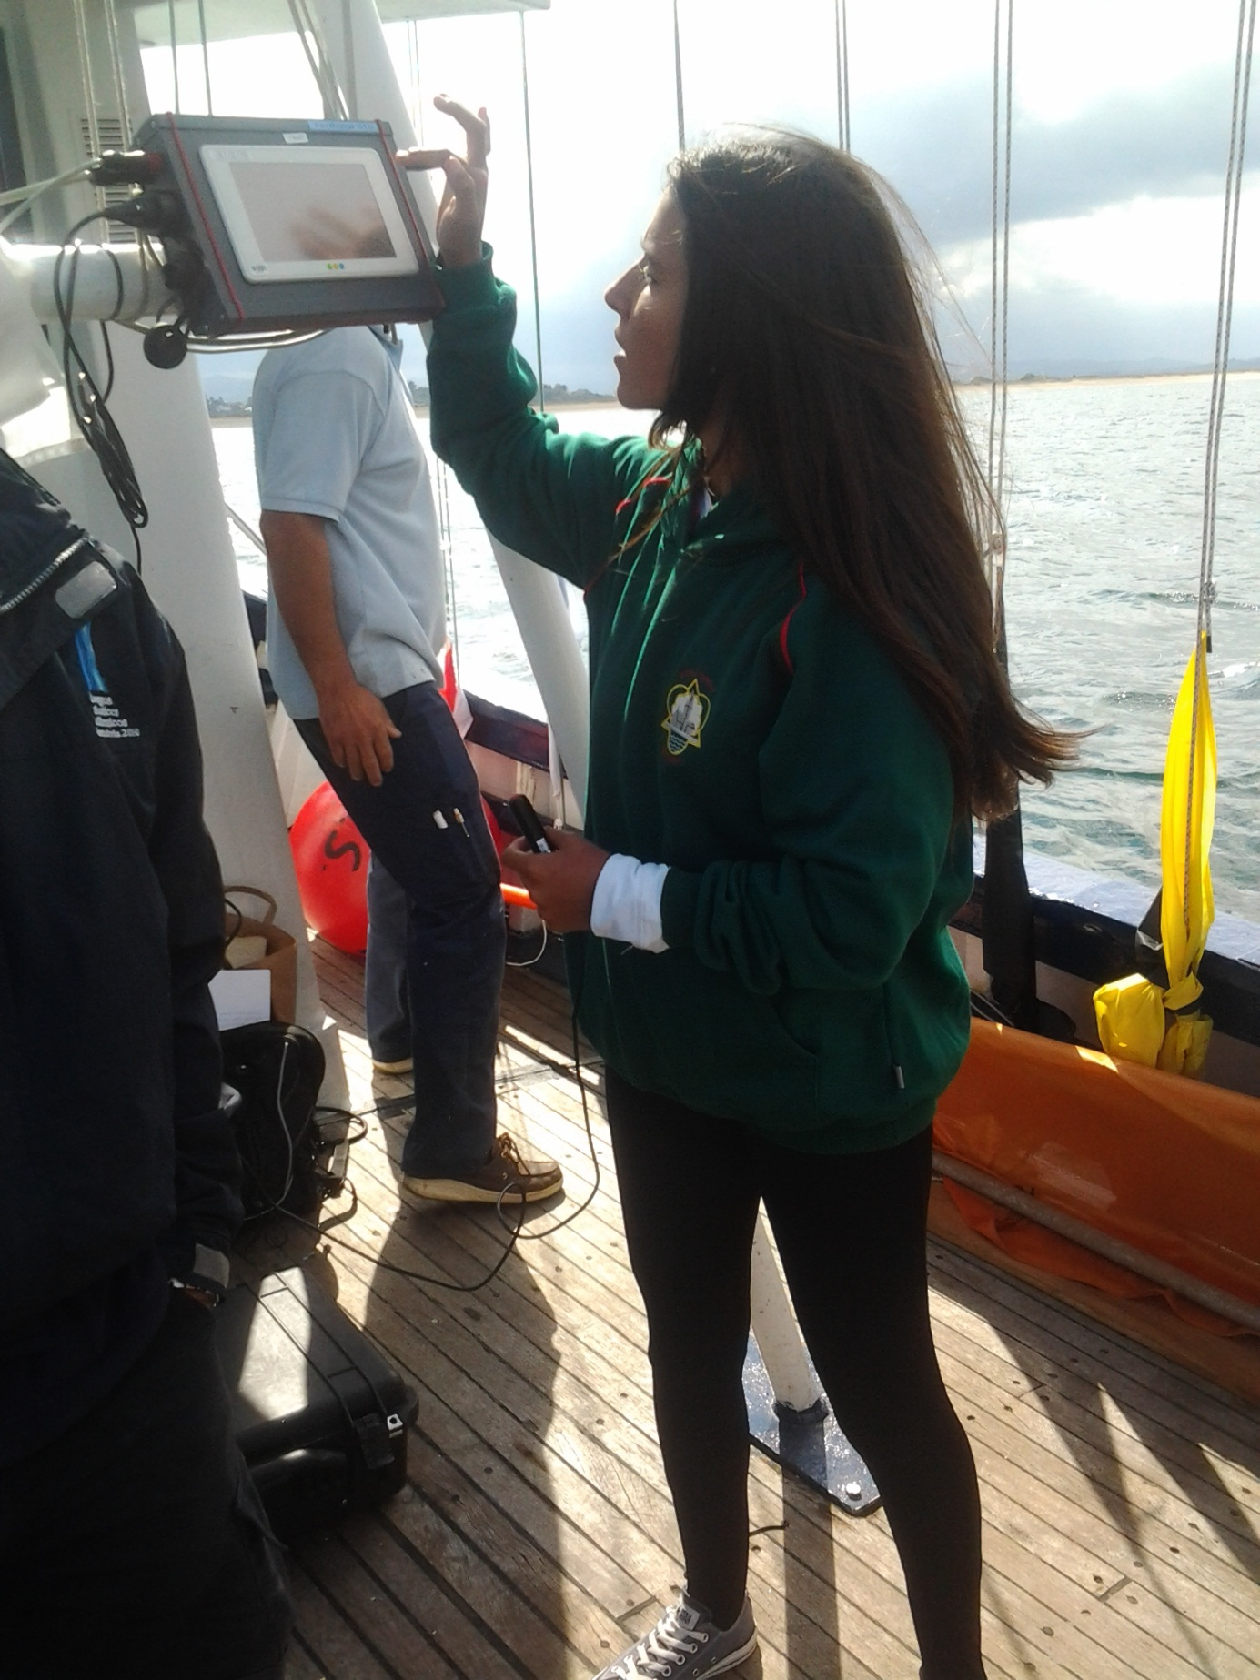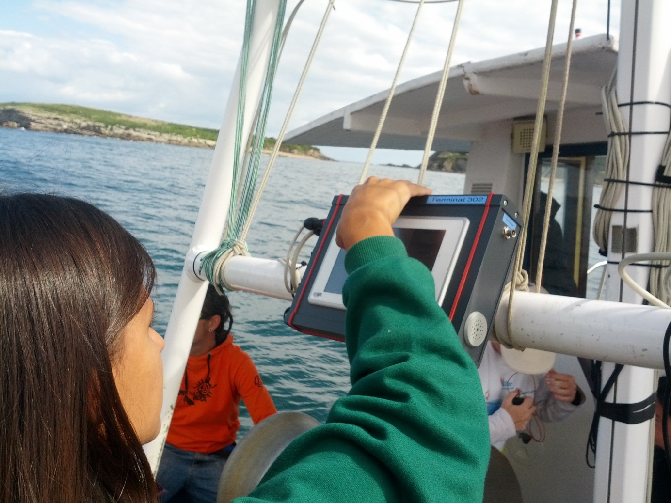

Flags that were shown on isaf site and updatet from another tablet on the boat 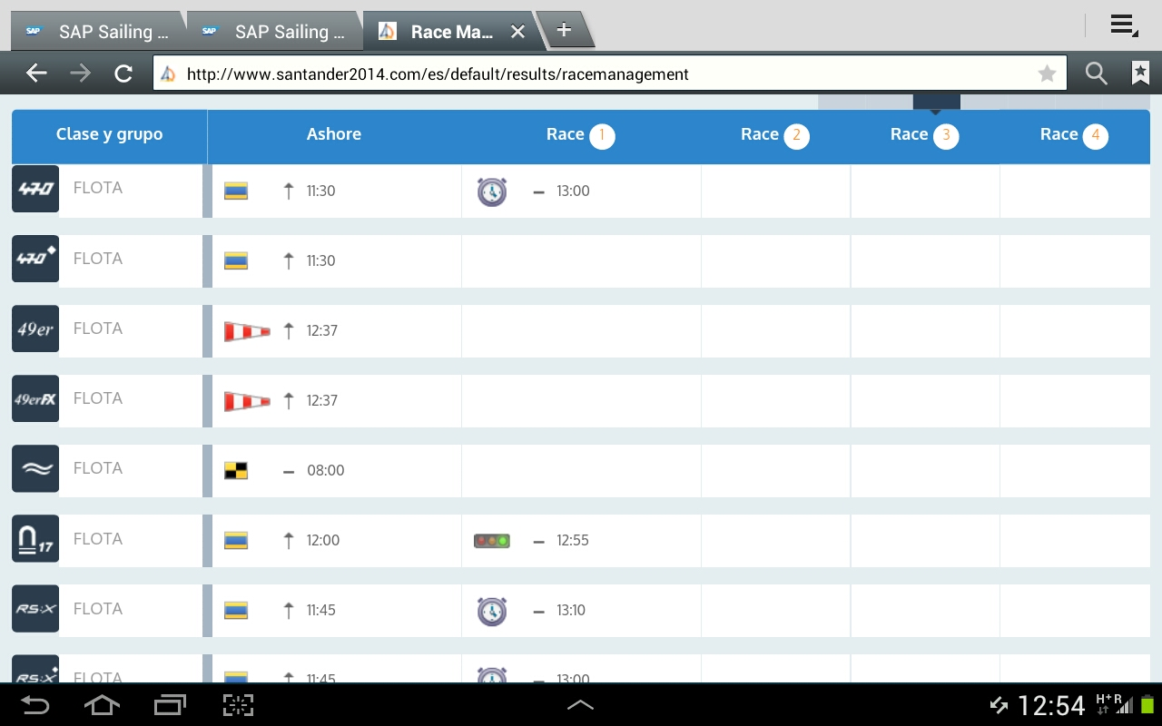

Startterminal

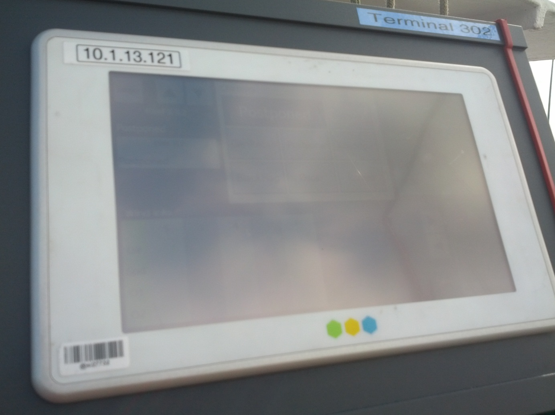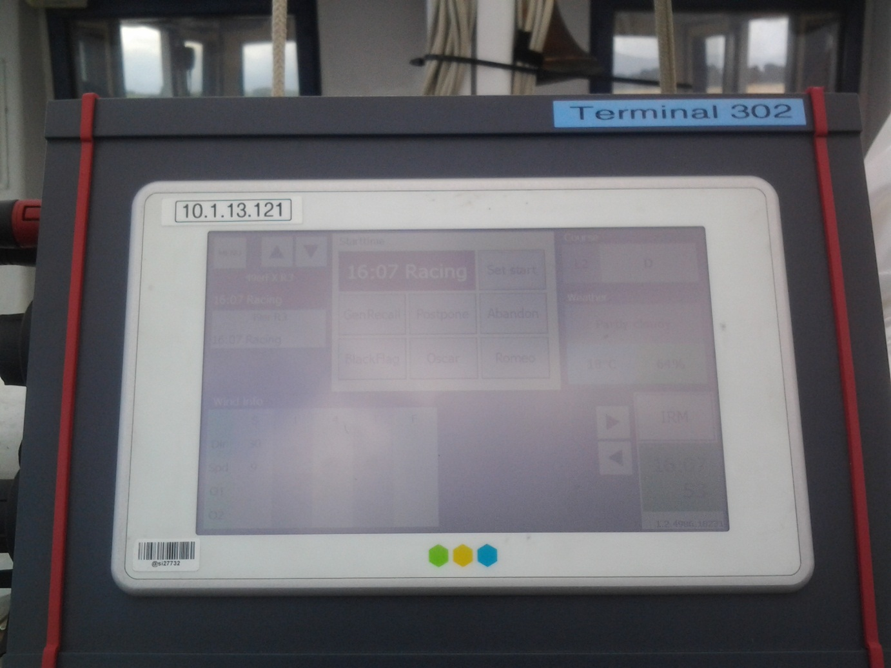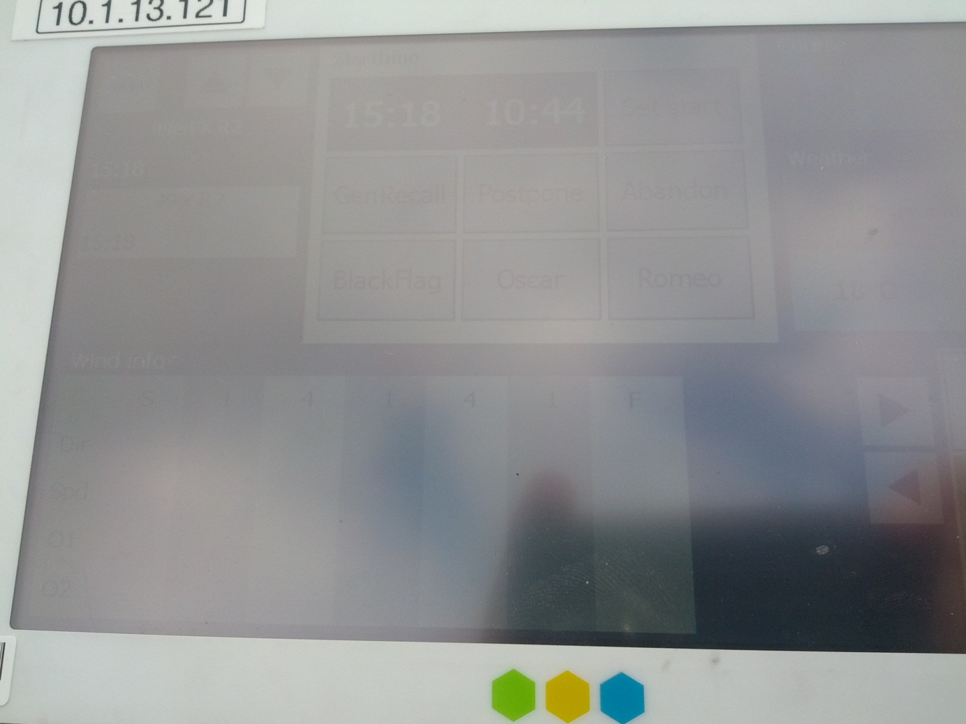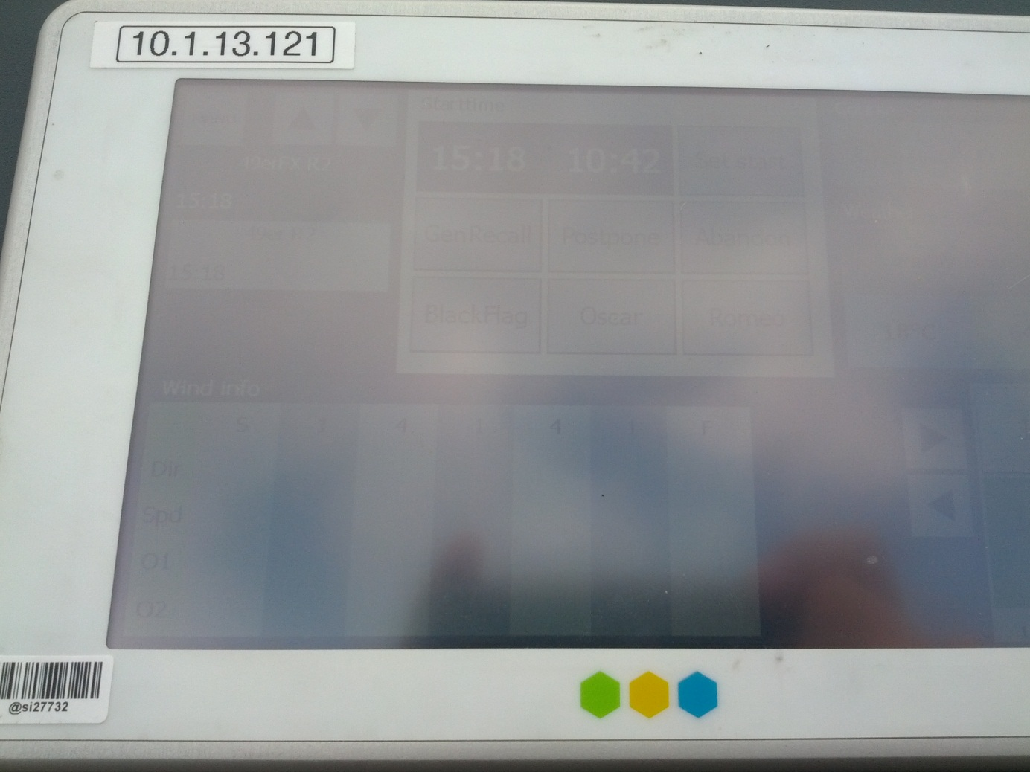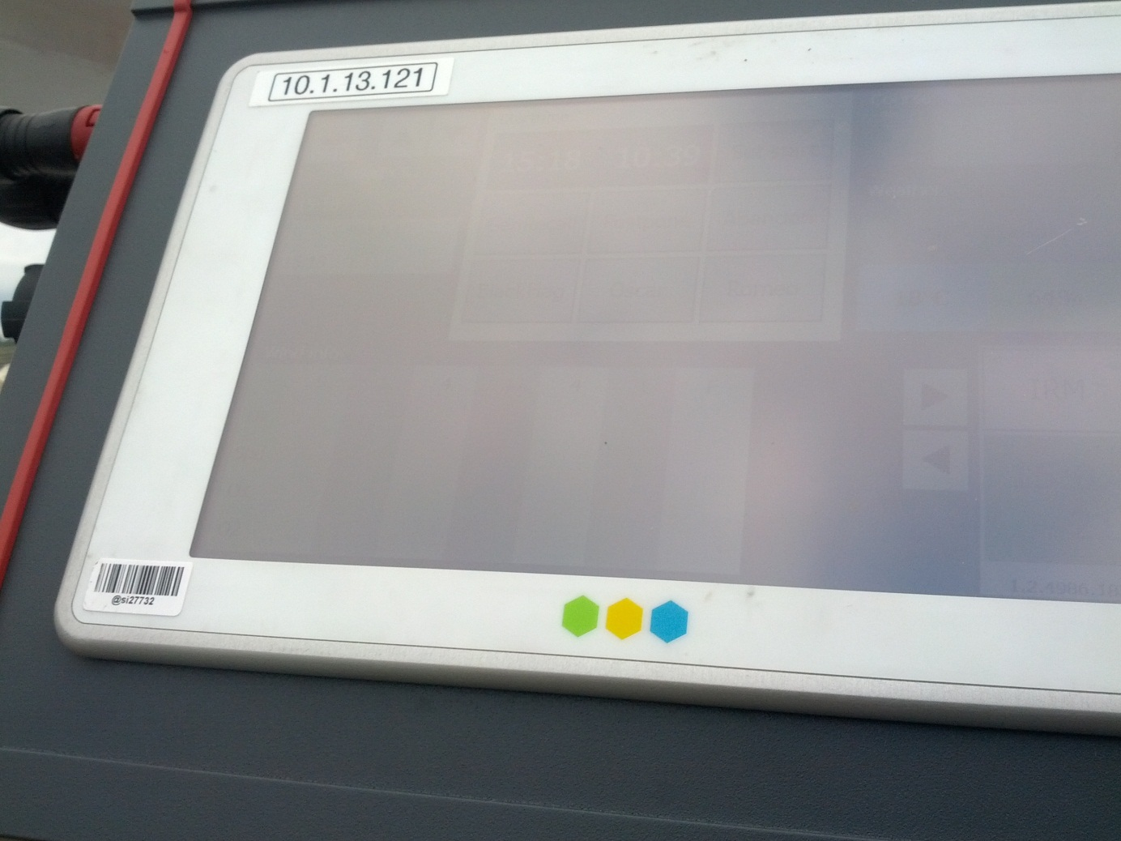

Finish Terminal

